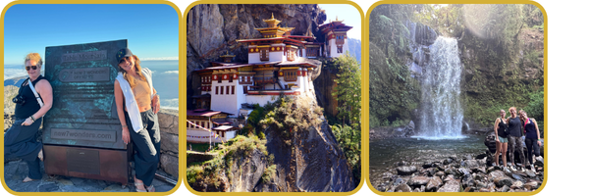

The Trips That Surprise Us
Hello,
Some destinations are exactly what you expect.
Others have a way of surprising you.
Lately, we've found ourselves talking about a few of those.
Bhutan: A Journey Unlike Any Other
Bhutan has been on our minds a lot recently.
Whilst many destinations have become increasingly busy, Bhutan remains refreshingly different. Visitor numbers are carefully managed; traditions are still very much part of everyday life and much of the country still feels untouched.
We've recently been putting together a 13-day journey through some of Bhutan's most beautiful valleys, combining spectacular scenery, gentle hiking, village life and just the right amount of culture.
The journey takes you through Thimphu, Punakha, Gangtey and Paro, with time to explore rather than simply rush between the main sights.
There are walks through the beautiful Phobjikha Valley, home to the endangered black-necked crane, time in traditional villages, monasteries and temples and, of course, the iconic hike to Tiger's Nest.
We've also discovered some very special places to stay.
Gangtey Lodge overlooks the Phobjikha Valley and has some of the finest views in Bhutan, whilst the intimate COMO Uma Punakha sits above the Mo Chhu River and feels like the perfect place to slow down after a day exploring.
The more we've looked at Bhutan, the more convinced we've become that this is one of those countries that needs to be experienced rather than simply described.
So much so, that Jill is now planning her own trip there with her husband next year. Which probably tells you everything you need to know about how we feel about Bhutan.

Did you know?
Bhutan is the world's only carbon-negative country, absorbing more carbon than it produces.
Visitors also contribute directly towards healthcare, education and conservation through the country's Sustainable Development Fee.
From a Marathon to a Safari
We've also recently shared the story of Crissa and Jenn's journey to South Africa.
What began with Crissa travelling to run the Cape Town Marathon became an unexpected friendship, followed by time exploring Cape Town, the Winelands and, for Jenn, an Eastern Cape safari.
It's one of those travel stories we particularly love because the journey became about far more than the places they visited.
Read Crissa and Jenn's story here
How a Solo Marathon Trip to Cape Town Turned into a Friendship, a Safari and a Journey Neither Traveler Expected
And Then There Was Panama...
The Tadman family have also recently returned from two weeks in Panama, and, by their own admission, they hadn't expected quite so much variety.
Panama City, cloud forests and waterfalls in Boquete, ziplining, sloths, howler monkeys, nesting turtles and time on both the Pacific and Caribbean coasts all fitted into one wonderfully easy journey.
Their photographs and feedback made us appreciate Panama all over again.
Read the Tadman family's Panama story here
Panama: One Country, So Many Surprises
The Trips That Stay with Us
Perhaps that's one of the things we enjoy most about planning travel.
Sometimes it's the destination itself. Other times it's an unexpected experience, a chance encounter or simply discovering somewhere you hadn't really considered before.
Bhutan, South Africa and Panama couldn't be more different, but each is a good reminder that the best journeys don't always unfold quite as you expect.
And often, that's exactly what makes them memorable.
With thanks,
John, Amanda & Jill
Opulent Travel
P.S. If you enjoy travel inspiration and the occasional behind-the-scenes glimpse, you'll also find us on Instagram @opulenttravelcompany and Facebook @OpulentTravelCompany.
If you would like to unsubscribe, simply reply with "unsubscribe".

