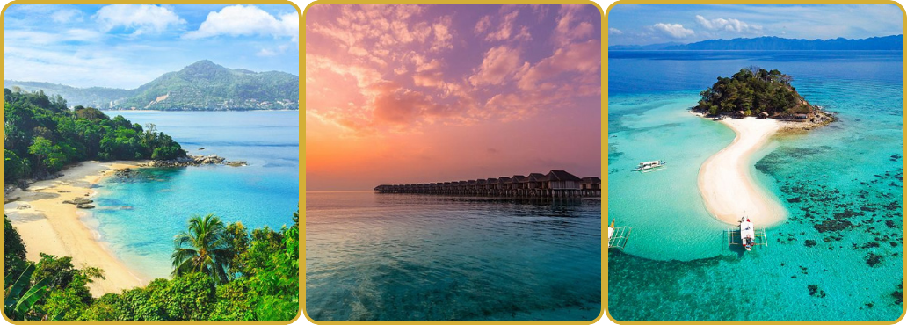

Beach Escapes We Love

Hello,
We recently shared five journeys we'd recommend everyone consider once in a lifetime, from Antarctica and Bhutan to Patagonia, Peru and Vietnam. The response was wonderful and sparked plenty of conversations about bucket-list adventures.
But sometimes the trip we're dreaming about isn't a major expedition at all.
Sometimes it's simply a few days by the sea.
Whether it is after a safari, as part of a honeymoon, or to celebrate a special occasion, a beach stay can be the perfect way to slow down, relax and recharge. This month, we thought we'd share some of our favourite beach destinations around the world.
For Overwater Villas and Ultimate Relaxation
Maldives
The Maldives remains the classic Indian Ocean escape.
Think overwater villas, turquoise lagoons, exceptional diving and some of the best resort spas in the world. It works beautifully for honeymoons, family trips and milestone celebrations and can be as active or as relaxed as you like.
Did you know?
The South Ari Atoll is one of the few places in the world where whale sharks can be seen year-round, making it a wonderful choice for snorkellers and divers.
For After Safari
Zanzibar
Zanzibar is one of our favourite places to unwind after safari.
It offers beautiful white-sand beaches, warm Indian Ocean waters and a fascinating blend of African, Arab and Indian influences. A few nights in Stone Town combined with time on the coast makes for a particularly rewarding trip.

Did you know?
Stone Town's unique architecture reflects centuries of African, Arab, Indian and European influence and is a UNESCO World Heritage Site.
For Island Hopping
Seychelles
Seychelles is ideal for those looking for a more varied island experience.
The dramatic granite boulders, lush interiors and excellent beaches give it a distinctive feel, and island-hopping works particularly well here. It is a wonderful option for honeymoons and longer, more relaxed trips.
Did you know?
The coco de mer palm produces the world's largest seed and is found naturally only in Seychelles.
For Beach and Culture
Sri Lanka
Sri Lanka combines beautiful coastline with culture, wildlife and some outstanding boutique hotels.
After exploring tea country, ancient sites or national parks, the beaches in the south offer the perfect place to relax.
Did you know?
Between November and April, blue whales can often be spotted off Sri Lanka's southern coast.
For Food, Beaches and Great Hotels
Thailand
Thailand offers a wonderful combination of beaches, food, culture and excellent value.
Whether staying on Koh Samui, Koh Yao Noi or along the Andaman coast, it is an easy and very rewarding destination.
One of our favourite places to stay is Six Senses Yao Noi, where spectacular views across Phang Nga Bay combine with one of the most relaxing settings in Southeast Asia.

For Divers and Island Lovers
Philippines
The Philippines is an excellent choice for divers and island lovers.
With thousands of islands, crystal-clear waters and exceptional marine life, it offers a more adventurous but still highly relaxing beach experience.
For Easy Access from the USA
Mexico
Mexico offers some superb beach escapes, from the Riviera Maya to the Pacific coast.
It works particularly well for U.S.-based travellers looking for a high-quality beach holiday with excellent food, stylish hotels and relatively easy flight connections.
For Something a Little Different
Brazil
Beyond Rio de Janeiro, destinations such as Paraty and the beaches of Bahia combine a relaxed seaside atmosphere with excellent food, culture and beautiful scenery.
Panama
Panama may not be the first place that comes to mind for a beach holiday, but it has some lovely options.
The Bocas del Toro archipelago offers laid-back Caribbean island charm and pairs beautifully with time in Panama City or the rainforest.
Did you know?
Panama has coastline on both the Pacific Ocean and Caribbean Sea, just a few hours apart.
A Few Places We'd Check Into Tomorrow
• Six Senses Yao Noi, Thailand - for the views across Phang Nga Bay and the feeling of being completely removed from the world.
• Cape Weligama, Sri Lanka - clifftop views, excellent food and an ideal place to unwind after exploring the country.
• Zuri Zanzibar, Zanzibar - a beautiful stretch of beach and one of our favourite places to relax after safari.
• Le Domaine de L'Orangeraie, Seychelles - a laid-back island retreat surrounded by granite boulders and tropical gardens.
If We Had Five Days By The Sea...

John: Zanzibar after safari. A few days on the beach after game drives is hard to beat.
Amanda: Thailand. A combination of Koh Samui and Koh Tao for beautiful beaches, fantastic food and plenty of time on the water.
Jill: Bocas del Toro in Panama. Laid-back Caribbean islands, great snorkelling and a wonderfully relaxed pace of life.

Currently Dreaming Of...
Whilst beach escapes are on our minds this month, our conversations have also been drifting towards some very different journeys.
Hiking to Tiger's Nest Monastery in Bhutan, exploring Patagonia's mountain trails, discovering Peru's Sacred Valley and cruising amongst Antarctica's icebergs.
One destination that has particularly captured our imagination recently is Bhutan. A country of mountain monasteries, peaceful valleys and remarkable lodges, it offers a style of travel that feels increasingly rare in today's world.
More on that next month...
And Finally...
These are just a few of our favourite places to relax by the sea.
Whether you are looking for overwater villas in the Maldives, a beach stay after safari, or a tropical escape closer to home, there are countless possibilities.
Where would you most like to spend a few days by the water?
With thanks,
John, Amanda & Jill
Opulent Travel
P.S. If you enjoy travel inspiration and the occasional behind-the-scenes glimpse, you'll also find us on Instagram @opulenttravelcompany and Facebook @OpulentTravelCompany.
If you would like to unsubscribe, simply reply with "unsubscribe."

